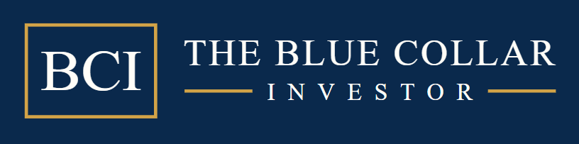

WEEKLY TOP PERFORMING ETFS
AS OF THE CLOSE ON 07/01/26

Each week, the BCI Team will screen ETFs (which also have options) from all asset classes and locate the top performers over the past 1 and 3-month periods. All selected ETFs have RS ratings of 60 or better over the past 3 months (unless otherwise stated). 1-week returns are not part of the screening process but are available as additional information.RS rating is in the context of all securities with minimum trading requirements. We also screen the S&P 500 Sector ETFs as well as publish the data on 4 inverse ETFs. ETFs with low trading volume (less than 250k/day) and leveraged ETFs are eliminated (with the exception of inverse ETFs to be used only in extreme bear markets). We also screen for adequate open interest at the time of the screening (100 contracts or more of OI and/or a bid-ask spread of $0.30 or less for near-the-money strikes).

Spreadsheet Key:
- ETF name
- ETF ticker symbol
- Price $: At the time the report was produced
- 1-WK %: 1-week price performance
- 1-MO %: 1-month price performance
- 3-MO %: 3-month price performance
- IV: Average implied volatility using call and put options
- Weeklys: A “Y” indicates that weekly options are available
- Sorting (order): Stocks are listed according to 1-month returns, best-to-worst

***BE CAREFUL WITH CHINEESE-BASED COMPANIES DUE TO TRANSPARENCY CONCERNS***
Mid-Week Market Tone (Republished from weekend)
IBD Stock Market Exposure (IBD metric)- amount recommended to be invested): 0% - 20%
GMI: 0/6- A bearish signal since March 6, 2026.
BCI: U.S. markets declined sharply today, marking the most negative Federal Open Market Committee decision-day reaction in more than a year. The sell-off was driven by a “hawkish hold” from the Federal Reserve, combined with mounting inflation concerns fueled by a spike in global oil prices. The Fed voted 11–1 to maintain the benchmark interest rate at 3.5%–3.75%, as expected; however, Chair Powell’s remarks unsettled investors. He indicated that progress on inflation has stalled and acknowledged that policymakers have discussed the potential for future rate hikes if price pressures persist. At the same time, escalating conflict with Iran pushed global oil prices higher, with Brent crude surpassing $109 per barrel and West Texas Intermediate (WTI) climbing nearly 3% to $96.21. Powell characterized this development as a significant and potentially prolonged “energy shock” that could further elevate inflation expectations. Adding to concerns, the Producer Price Index (PPI) rose 0.7% in February, well above the 0.3% forecast—suggesting that wholesale inflation was already gaining momentum even before the recent surge in energy costs. No change to the defensive bias when crafting my trades.
Top-Performing ETFs: 06/26/26

Additional Information

Select Sector SPDRs
Select Sector SPDRs are unique ETFs that divide the S&P 500 into 11 sector index funds. They have the diversity of mutual funds, the focus of a sector fund, and the tradability of a stock. Together, the 11 Select Sector SPDRs represent the S&P 500 as a whole. However, each Select Sector SPDR can also be bought individually, providing you with exposure to a particular sector or industry group.
These securities all have options and can be used with our covered call strategy. Each week the BCI Team will do a 1-month and 3-month technical analysis of the linear price chart of each sector and compare it to the performance of the S&P itself. The funds outperforming the market benchmark in these time frames will be listed and considered to be among the best candidates for covered call writing in the near term. The 11 Select Sector SPDRs are:
- Consumer Discretionary (XLY)
- Consumer Staples (XLP)
- Energy (XLE)
- Financials (XLF)
- Health Care (XLV)
- Industrials (XLI)
- Materials (XLB)
- Real Estate (XLRE)
- Technology (XLK)
- Utilities (XLU)
- Communications (XLC)
Inverse Exchange-Traded Funds
Inverse ETFs use derivatives to bet against the direction of financial markets. These are known as short or bear ETFs and will make money if markets decline in value. They will lose money, however, if markets move against the bet. Covered call writers who have a bearish market outlook may find these funds useful. Inverse ETFs will UNDERPERFORM in normal market conditions. The following inverse ETFs will be analyzed and compared to the S&P 500 in the spreadsheet:
PSQ: Short QQQ (Nasdaq-100)
DOG: Short Dow 30 (DJIA)
SH: Short S&P 500 (S&P 500)
RWM: Short Russell 2000 (Russell 2000)
Current Implied Volatility (IV) of Eligible ETFs
Implied volatility is a forecast of the underlying security’s volatility as implied by the options price in the marketplace. It measures potential risk. Generally, the higher the IV, the greater the risk and the higher the premiums. We also show the current IV of the S&P 500 as a means of comparison.
We use a weighted average of implied volatility using put and call options. This ETF Report as well as our premium Stock Reports can be used for both covered call writing and selling cash-secured puts.

Our positions are managed by our BCI exit strategy guidelines NOT by a security being removed from last week’s (month’s) report. If we need a replacement stock for a new position, use the most recent report.

